Commentary on the Titanic

The first thing that jumps out at anyone doing an analysis of who survived the sinking of the Titanic is if you were a second or third-class adult male, then your chances were particularly bleak. So much so that one Machine-Learning programmer titled his program ‘Jack dies’.

Where things get even more interesting though is when we look at the relative importance of the main factors affecting your likelihood of survival if you were on the Titanic: sex, age and class. James Cameron’s movie ‘Titanic’ implied class was the dominant factor. The movie did depict women being evacuated before men and in the end Jack makes the ultimate sacrifice. But class was the dominant theme throughout.

An exploratory analysis of data on the survivors, as well as machine learning analysis shows the role of gender to be particularly interesting, and says a lot about the moral code on the Titanic. Looking at the graph of how survival rates per class change by sex, we can see that not only were women more likely to survive within each class, but third-class women were more likely to survive than first-class men. This same result shows up in the table. Adult males in first class had a 37.5% likelihood of survival whereas adult females in third class had a 42.4% likelihood of survival. For this to have happened, the notion of “women and children first” would have had to have been taken very seriously as a cultural norm. Not only did the men in first class have easier access to the boats but bringing the women up from third class would have increased the possibility of men in third class making a break for the boats ahead of the men in first class. So while class heavily influenced survival within the two sexes, the ship’s crewmen and the men in first class were willing to not only put the women in first class ahead of the men in first class, but they also were willing to lower their own chances of survival in order to put the women in third class ahead of them.

The ‘Titanic’ references the lifeboats not being fully packed with people, and the allusion in the movie is again towards class differences. This is partly true, but with men in first class having a lower survival rate than women in third class the biggest driver for the less-than-full boats was the desire of the men aboard to maximize the survival chances of their women and children.

Overall survival:

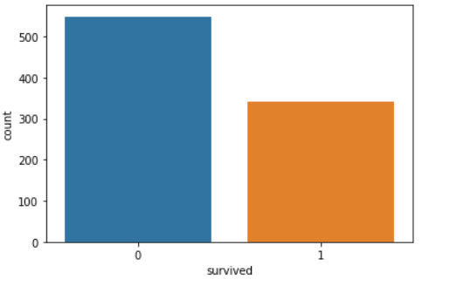

Plot of who survived: how survival within each class changes by sex

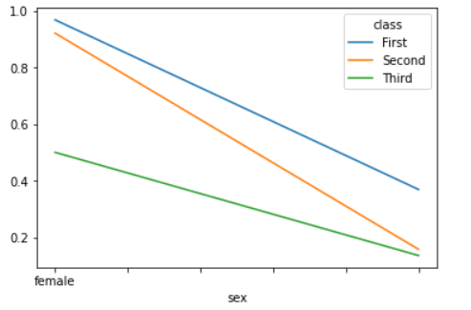

Breakdown by age, sex and class in table format:

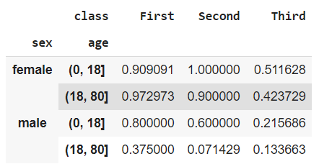

Breaking down further by age we can see that, in contrast to today’s era, when anyone under 18 would classify as a child, 100 years ago you needed to be a much younger child to receive the benefit of ‘women and children first’.

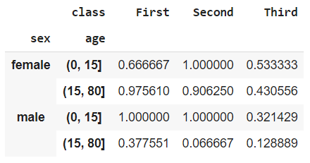

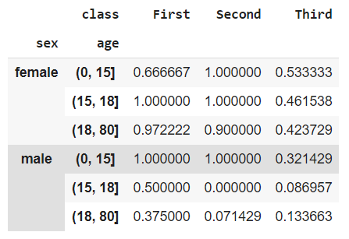

The machine learning results come to similar conclusions. One interesting thing is that although the class (shown as ‘pclass’) has a relatively lower impact on survival, behind ‘age’ and ‘sex’ the fare paid (‘fare’) has a high impact. More analysis needs to be done on this.

